Практическая работа 11
Тема: «Методы обеспечения и контроля качества»

Цель: изучение методов статистического контроля качества процессов с использованием индексов воспроизводимости, а также приобретение практических навыков работы с программным обеспечением для анализа качества.

Ход работы
- Индекс воспроизводимости.
Индекс воспроизводимости показывает, соответствует ли разброс процесса ширине поля допуска. Он рассчитывается по формуле:
$$C_{p}=\frac{USL-LSL}{6σ}$$
Где:
$USL$ – верхняя граница допуска;
$LSL$ – нижняя граница допуска;
$σ$ – стандартное отклонение процесса.
Интерпретация значений:
- $C_{p}$ ≥ 1.33 – отличная воспроизводимость (процесс пригоден);
- $C_{p}$ ≥ 1.0 – удовлетворительная воспроизводимость (требуется контроль);
- $C_{p}$ ≥ 0.67 – неудовлетворительная воспроизводимость (требуется улучшение);
- $C_{p}$ < 0.67 – критическая воспроизводимость (процесс непригоден).
- Индекс пригодности.
Индекс пригодности учитывает не только разброс, но и центрированность процесса относительно середины поля допуска. Он рассчитывается по формуле:
$$C_{pk}=\min\left(\frac{USL-μ}{3σ},\frac{μ-LSL}{3σ}\right)$$
Где:
$μ$ – среднее арифметическое процесса;
$σ$ – стандартное отклонение процесса;
$USL$ – верхняя граница допуска;
$LSL$ – нижняя граница допуска.
Следовательно у нас есть 4 варианта для обоих формул
- ОТЛИЧНО (Cp ≥ 1.33, Cpk ≥ 1.33)
$$C_{p}=\frac{10-0}{6*1}=\frac{10}{6}≈1.66$$
$$C_{pk}=\min\left(\frac{10-5}{3*1},\frac{5-0}{3*1}\right)=min\left(\frac{5}{3},\frac{5}{3}\right)=\frac{5}{3}≈1.66$$
- УДОВЛЕТВОРИТЕЛЬНО (Cp ≥ 1.0, Cpk ≥ 1.0)
$$C_{p}=\frac{8-2}{6*1}=\frac{6}{6}=1$$
$$C_{pk}=\min\left(\frac{8-5}{3*1},\frac{5-2}{3*1}\right)=min\left(\frac{3}{3},\frac{3}{3}\right)=\frac{3}{3}=1$$
- НЕУДОВЛЕТВОРИТЕЛЬНО (Cp ≥ 0.67, Cpk ≥ 0.67)
$$C_{p}=\frac{6-2}{6*1}=\frac{4}{6}≈0.66$$
$$C_{pk}=\min\left(\frac{6-4}{3*1},\frac{4-2}{3*1}\right)=min\left(\frac{2}{3},\frac{2}{3}\right)=\frac{2}{3}≈0.66$$
- КРИТИЧНО (Cp < 0.67, Cpk < 0.67)
$$C_{p}=\frac{4-2}{6*1}=\frac{2}{6}≈0.33$$
$$C_{pk}=\min\left(\frac{4-3}{3*1},\frac{3-2}{3*1}\right)=min\left(\frac{1}{3},\frac{1}{3}\right)=\frac{1}{3}≈0.33$$

- Дизайн
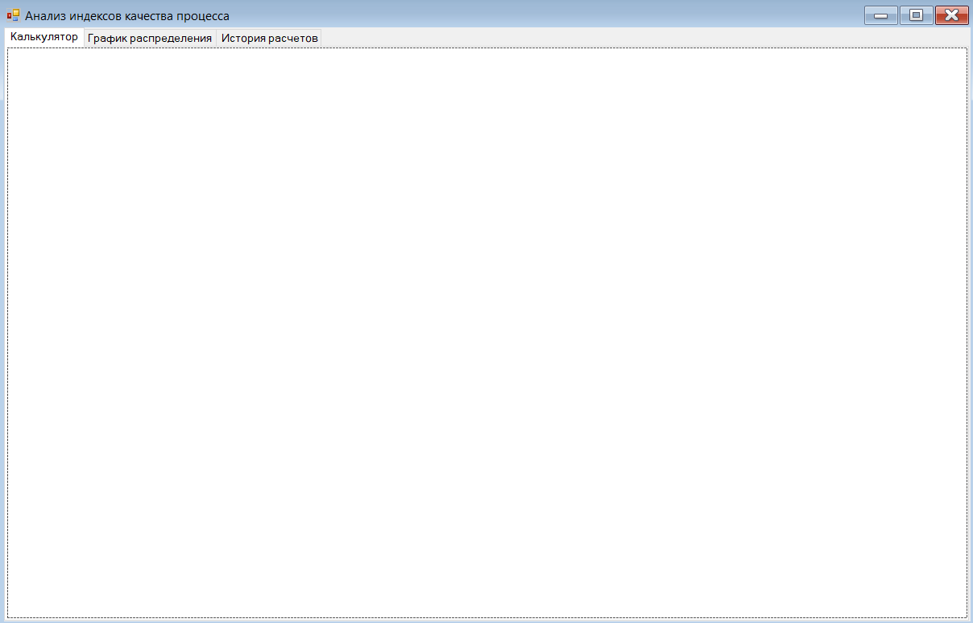
- Код
using System;
using System.Windows.Forms;

namespace QualityIndicesAnalyzer
{
public partial class Form1 : Form
{
private CalculatorControl calculatorControl;
private ChartControl chartControl;
private HistoryControl historyControl;

public Form1()
{
InitializeComponent();
InitializeControls();
}

private void InitializeControls()
{
calculatorControl = new CalculatorControl();
chartControl = new ChartControl();
historyControl = new HistoryControl();

tabCalculator.Controls.Add(calculatorControl);
tabChart.Controls.Add(chartControl);
tabHistory.Controls.Add(historyControl);

chartControl.SetCalculatorReference(calculatorControl);

calculatorControl.CalculationSaved += (s, data) =>
{
historyControl.AddToHistory(data);
};

historyControl.CalculationSelected += (s, data) =>
{
calculatorControl.LoadCalculation(data);
tabControl.SelectedTab = tabCalculator;
};
}

}
}
using System;

namespace QualityIndicesAnalyzer
{
public class CalculationData
{
public DateTime Timestamp { get; set; }
public double USL { get; set; }
public double LSL { get; set; }
public double Mean { get; set; }
public double StdDev { get; set; }
public double Cp { get; set; }
public double Cpk { get; set; }
public string Interpretation { get; set; }

public CalculationData(double usl, double lsl, double mean, double stdDev, double cp, double cpk, string interpretation)
{
Timestamp = DateTime.Now;
USL = usl;
LSL = lsl;
Mean = mean;
StdDev = stdDev;
Cp = cp;
Cpk = cpk;
Interpretation = interpretation;
}

}
}
using System;
using System.Collections.Generic;
using System.Drawing;
using System.Windows.Forms;
using System.Drawing.Drawing2D;

namespace QualityIndicesAnalyzer
{
public class ChartControl : UserControl
{
private Panel drawingPanel;
private Label lblTitle;
private Label lblCpCpkInfo;
private Button btnRefresh;
private CalculatorControl calculatorRef;

private Label lblLegendNormal;
private Label lblLegendInSpec;
private Label lblLegendBelow;
private Label lblLegendAbove;
private Label lblLSLValue;
private Label lblUSLValue;
private Label lblMeanValue;

private Label lblXAxisTitle;

private Panel pnlYAxisTitle;

private double usl, lsl, mean, stdDev;
private double cp, cpk;

private Color colorNormal = Color.Blue;
private Color colorInSpec = Color.FromArgb(200, Color.LightGreen);
private Color colorBelow = Color.FromArgb(150, Color.Red);
private Color colorAbove = Color.FromArgb(150, Color.Red);

public ChartControl()
{
InitializeControls();
}

public void SetCalculatorReference(CalculatorControl calculator)
{
calculatorRef = calculator;
}

private void InitializeControls()
{
this.Size = new Size(880, 650);
this.BackColor = Color.White;
this.AutoScroll = true;

btnRefresh = new Button
{
Text = "Обновить график",
Location = new Point(20, 20),
Size = new Size(150, 30),
BackColor = Color.LightBlue
};
btnRefresh.Click += BtnRefresh_Click;

lblCpCpkInfo = new Label
{
Location = new Point(200, 25),
Size = new Size(300, 20),
Font = new Font("Arial", 12, FontStyle.Bold),
ForeColor = Color.DarkBlue
};

drawingPanel = new Panel
{
Location = new Point(70, 60),
Size = new Size(540, 400),
BorderStyle = BorderStyle.FixedSingle,
BackColor = Color.White
};
drawingPanel.Paint += DrawingPanel_Paint;

pnlYAxisTitle = new Panel
{
Location = new Point(5, 150),
Size = new Size(40, 250),
BackColor = Color.Transparent
};
pnlYAxisTitle.Paint += (s, e) => {
Graphics g = e.Graphics;
g.SmoothingMode = SmoothingMode.AntiAlias;

var state = g.Save();
g.TranslateTransform(pnlYAxisTitle.Width / 2, pnlYAxisTitle.Height / 2);
g.RotateTransform(-90);

string text = "Плотность вероятности";
using (Font font = new Font("Arial", 10, FontStyle.Bold))
using (Brush brush = new SolidBrush(Color.Black))
{
SizeF textSize = g.MeasureString(text, font);
g.DrawString(text, font, brush, -textSize.Width / 2, -textSize.Height / 2);
}

g.Restore(state);
};

lblXAxisTitle = new Label
{
Text = "Значение",
Location = new Point(300, 470),
Size = new Size(100, 20),
Font = new Font("Arial", 10, FontStyle.Bold),
TextAlign = ContentAlignment.MiddleCenter
};

int legendX = 650;
int legendY = 60;
int lineHeight = 25;

Label lblLegendTitle = new Label
{
Text = "Обозначения:",
Location = new Point(legendX, legendY),
Size = new Size(200, 20),
Font = new Font("Arial", 10, FontStyle.Bold)
};

Panel pnlNormalColor = new Panel
{
Location = new Point(legendX, legendY + lineHeight),
Size = new Size(20, 15),
BackColor = colorNormal
};
lblLegendNormal = new Label
{
Text = "Нормальное распределение",
Location = new Point(legendX + 25, legendY + lineHeight - 2),
Size = new Size(180, 20)
};

Panel pnlInSpecColor = new Panel
{
Location = new Point(legendX, legendY + lineHeight * 2),
Size = new Size(20, 15),
BackColor = colorInSpec
};
lblLegendInSpec = new Label
{
Text = "В допуске",
Location = new Point(legendX + 25, legendY + lineHeight * 2 - 2),
Size = new Size(180, 20)
};

Panel pnlBelowColor = new Panel
{
Location = new Point(legendX, legendY + lineHeight * 3),
Size = new Size(20, 15),
BackColor = colorBelow
};
lblLegendBelow = new Label
{
Text = "Ниже допуска",
Location = new Point(legendX + 25, legendY + lineHeight * 3 - 2),
Size = new Size(180, 20)
};

Panel pnlAboveColor = new Panel
{
Location = new Point(legendX, legendY + lineHeight * 4),
Size = new Size(20, 15),
BackColor = colorAbove
};
lblLegendAbove = new Label
{
Text = "Выше допуска",
Location = new Point(legendX + 25, legendY + lineHeight * 4 - 2),
Size = new Size(180, 20)
};

int infoY = legendY + lineHeight * 5 + 30;

Label lblLSLText = new Label
{
Text = "LSL =",
Location = new Point(legendX, infoY),
Size = new Size(50, 20),
Font = new Font("Arial", 9, FontStyle.Bold)
};

lblLSLValue = new Label
{
Location = new Point(legendX + 50, infoY),
Size = new Size(80, 20),
ForeColor = Color.Red
};

Label lblUSLText = new Label
{
Text = "USL =",
Location = new Point(legendX, infoY + lineHeight),
Size = new Size(50, 20),
Font = new Font("Arial", 9, FontStyle.Bold)
};

lblUSLValue = new Label
{
Location = new Point(legendX + 50, infoY + lineHeight),
Size = new Size(80, 20),
ForeColor = Color.Red
};

Label lblMeanText = new Label
{
Text = "Среднее =",
Location = new Point(legendX, infoY + lineHeight * 2),
Size = new Size(70, 20),
Font = new Font("Arial", 9, FontStyle.Bold)
};

lblMeanValue = new Label
{
Location = new Point(legendX + 70, infoY + lineHeight * 2),
Size = new Size(80, 20),
ForeColor = Color.Green
};

this.Controls.AddRange(new Control[] {
btnRefresh, lblCpCpkInfo, drawingPanel,
pnlYAxisTitle, lblXAxisTitle,
lblLegendTitle, pnlNormalColor, lblLegendNormal,
pnlInSpecColor, lblLegendInSpec,
pnlBelowColor, lblLegendBelow,
pnlAboveColor, lblLegendAbove,
lblLSLText, lblLSLValue,
lblUSLText, lblUSLValue,
lblMeanText, lblMeanValue
});
}

private void BtnRefresh_Click(object sender, EventArgs e)
{
if (calculatorRef != null)
{
var data = calculatorRef.GetCurrentData();
if (data != null)
{
usl = data.USL;
lsl = data.LSL;
mean = data.Mean;
stdDev = data.StdDev;
cp = data.Cp;
cpk = data.Cpk;

lblCpCpkInfo.Text = $"Cp = {cp:F3}, Cpk = {cpk:F3}";
lblLSLValue.Text = $"{lsl:F3}";
lblUSLValue.Text = $"{usl:F3}";
lblMeanValue.Text = $"{mean:F3}";

drawingPanel.Invalidate();
pnlYAxisTitle.Invalidate();
}
else
{
drawingPanel.Invalidate();
MessageBox.Show("Сначала выполните расчет на вкладке 'Калькулятор'!",
"Нет данных", MessageBoxButtons.OK, MessageBoxIcon.Warning);
}
}
}

private void DrawingPanel_Paint(object sender, PaintEventArgs e)
{
Graphics g = e.Graphics;
g.SmoothingMode = SmoothingMode.AntiAlias;
g.Clear(Color.White);

int width = drawingPanel.Width;
int height = drawingPanel.Height;

int marginLeft = 60;
int marginRight = 30;
int marginTop = 20;
int marginBottom = 40;

Pen axisPen = new Pen(Color.Black, 1);

g.DrawLine(axisPen, marginLeft, height - marginBottom, width - marginRight, height - marginBottom);
g.DrawLine(axisPen, marginLeft, marginTop, marginLeft, height - marginBottom);

int chartWidth = width - marginLeft - marginRight;
int chartHeight = height - marginTop - marginBottom;

int numXTicks = 7;
for (int i = 0; i < numXTicks; i++)
{
double percent = (double)i / (numXTicks - 1);
int xPos = marginLeft + (int)(percent * chartWidth);

g.DrawLine(axisPen, xPos, height - marginBottom, xPos, height - marginBottom + 5);
}

int numYTicks = 5;
for (int i = 0; i < numYTicks; i++)
{
double percent = (double)i / (numYTicks - 1);
int yPos = height - marginBottom - (int)(percent * chartHeight);

g.DrawLine(axisPen, marginLeft - 5, yPos, marginLeft, yPos);
}

if (stdDev <= 0 || usl <= lsl)
{
using (Font font = new Font("Arial", 12))
using (StringFormat sf = new StringFormat())
{
sf.Alignment = StringAlignment.Center;
sf.LineAlignment = StringAlignment.Center;

g.DrawString("Нет данных для отображения",
font, Brushes.Gray,
new RectangleF(0, 0, width, height),
sf);
}
return;
}

double minX = Math.Min(lsl - 2 * stdDev, mean - 4 * stdDev);
double maxX = Math.Max(usl + 2 * stdDev, mean + 4 * stdDev);
double rangeX = maxX - minX;

Func<double, double> normalDist = (x) =>
{
return (1.0 / (stdDev * Math.Sqrt(2 * Math.PI))) *
Math.Exp(-0.5 * Math.Pow((x - mean) / stdDev, 2));
};

double maxY = 0;
for (double x = minX; x <= maxX; x += rangeX / 200)
{
maxY = Math.Max(maxY, normalDist(x));
}
maxY *= 1.1;

for (int i = 0; i < numXTicks; i++)
{
double xValue = minX + (rangeX / (numXTicks - 1)) * i;
int xPos = marginLeft + (int)((xValue - minX) / rangeX * chartWidth);

string xLabel = xValue.ToString("F1");
SizeF labelSize = g.MeasureString(xLabel, SystemFonts.DefaultFont);
g.DrawString(xLabel, SystemFonts.DefaultFont, Brushes.Black,
xPos - labelSize.Width / 2, height - marginBottom + 8);
}

for (int i = 0; i < numYTicks; i++)
{
double yValue = (maxY / (numYTicks - 1)) * i;
int yPos = height - marginBottom - (int)((yValue / maxY) * chartHeight);

string yLabel = yValue.ToString("F2");
SizeF labelSize = g.MeasureString(yLabel, SystemFonts.DefaultFont);
g.DrawString(yLabel, SystemFonts.DefaultFont, Brushes.Black,
marginLeft - 8 - labelSize.Width, yPos - labelSize.Height / 2);
}

int lslXPos = marginLeft + (int)((lsl - minX) / rangeX * chartWidth);
int uslXPos = marginLeft + (int)((usl - minX) / rangeX * chartWidth);
int meanXPos = marginLeft + (int)((mean - minX) / rangeX * chartWidth);

lslXPos = Math.Max(marginLeft, Math.Min(width - marginRight, lslXPos));
uslXPos = Math.Max(marginLeft, Math.Min(width - marginRight, uslXPos));
meanXPos = Math.Max(marginLeft, Math.Min(width - marginRight, meanXPos));

List<PointF> points = new List<PointF>();
for (double x = minX; x <= maxX; x += rangeX / 500)
{
double y = normalDist(x);
int screenX = marginLeft + (int)((x - minX) / rangeX * chartWidth);
int screenY = height - marginBottom - (int)((y / maxY) * chartHeight);

screenY = Math.Max(marginTop, Math.Min(height - marginBottom, screenY));

points.Add(new PointF(screenX, screenY));
}

if (points.Count > 1)
{
using (Pen curvePen = new Pen(colorNormal, 2))
{
g.DrawLines(curvePen, points.ToArray());
}

using (Brush inSpecBrush = new SolidBrush(colorInSpec))
using (Brush outSpecBrush = new SolidBrush(colorBelow))
{
if (lslXPos > marginLeft)
{
GraphicsPath belowPath = new GraphicsPath();
belowPath.AddLine(marginLeft, height - marginBottom, lslXPos, height - marginBottom);

for (double x = minX; x <= lsl; x += rangeX / 200)
{
if (x > maxX) break;
double y = normalDist(x);
int screenX = marginLeft + (int)((x - minX) / rangeX * chartWidth);
int screenY = height - marginBottom - (int)((y / maxY) * chartHeight);
screenY = Math.Max(marginTop, Math.Min(height - marginBottom, screenY));
belowPath.AddLine(screenX, screenY, screenX, screenY);
}

belowPath.AddLine(lslXPos, height - marginBottom, marginLeft, height - marginBottom);
g.FillPath(outSpecBrush, belowPath);
}

if (uslXPos < width - marginRight)
{
GraphicsPath abovePath = new GraphicsPath();
abovePath.AddLine(uslXPos, height - marginBottom, width - marginRight, height - marginBottom);

for (double x = maxX; x >= usl; x -= rangeX / 200)
{
if (x < minX) break;
double y = normalDist(x);
int screenX = marginLeft + (int)((x - minX) / rangeX * chartWidth);
int screenY = height - marginBottom - (int)((y / maxY) * chartHeight);
screenY = Math.Max(marginTop, Math.Min(height - marginBottom, screenY));
abovePath.AddLine(screenX, screenY, screenX, screenY);
}

abovePath.AddLine(width - marginRight, height - marginBottom, uslXPos, height - marginBottom);
g.FillPath(outSpecBrush, abovePath);
}

if (uslXPos > lslXPos)
{
GraphicsPath inSpecPath = new GraphicsPath();
inSpecPath.AddLine(lslXPos, height - marginBottom, uslXPos, height - marginBottom);

for (double x = lsl; x <= usl; x += rangeX / 200)
{
double y = normalDist(x);
int screenX = marginLeft + (int)((x - minX) / rangeX * chartWidth);
int screenY = height - marginBottom - (int)((y / maxY) * chartHeight);
screenY = Math.Max(marginTop, Math.Min(height - marginBottom, screenY));
inSpecPath.AddLine(screenX, screenY, screenX, screenY);
}

inSpecPath.AddLine(uslXPos, height - marginBottom, lslXPos, height - marginBottom);
g.FillPath(inSpecBrush, inSpecPath);
}
}

using (Pen lslPen = new Pen(Color.Red, 1))
{
lslPen.DashStyle = DashStyle.Dash;
g.DrawLine(lslPen, lslXPos, marginTop, lslXPos, height - marginBottom);
}

using (Pen uslPen = new Pen(Color.Red, 1))
{
uslPen.DashStyle = DashStyle.Dash;
g.DrawLine(uslPen, uslXPos, marginTop, uslXPos, height - marginBottom);
}

using (Pen meanPen = new Pen(Color.Green, 1))
{
meanPen.DashStyle = DashStyle.Dot;
g.DrawLine(meanPen, meanXPos, marginTop, meanXPos, height - marginBottom);
}
}
}

public CalculationData GetCurrentData()
{
if (stdDev > 0 && usl > lsl)
{
return new CalculationData(usl, lsl, mean, stdDev, cp, cpk,
GetInterpretation(Math.Min(cp, cpk)));
}
return null;
}

private string GetInterpretation(double value)
{
if (value >= 1.33)
return "Отлично (процесс пригоден, обычный контроль)";
else if (value >= 1.0)
return "Удовлетворительно (требуется усиленный контроль)";
else if (value >= 0.67)
return "Неудовлетворительно (требуется улучшение процесса)";
else
return "Критично (процесс непригоден, требуется остановка)";
}
}
}
using System;

using System.Windows.Forms;
using System.Globalization;
using System.IO;
using System.Text;
using DocumentFormat.OpenXml;
using DocumentFormat.OpenXml.Packaging;
using DocumentFormat.OpenXml.Wordprocessing;
using Paragraph = DocumentFormat.OpenXml.Wordprocessing.Paragraph;
using Table = DocumentFormat.OpenXml.Wordprocessing.Table;
using TableRow = DocumentFormat.OpenXml.Wordprocessing.TableRow;
using TableCell = DocumentFormat.OpenXml.Wordprocessing.TableCell;
using Text = DocumentFormat.OpenXml.Wordprocessing.Text;
using Run = DocumentFormat.OpenXml.Wordprocessing.Run;
using Bold = DocumentFormat.OpenXml.Wordprocessing.Bold;
using Justification = DocumentFormat.OpenXml.Wordprocessing.Justification;
using JustificationValues = DocumentFormat.OpenXml.Wordprocessing.JustificationValues;
using FontSize = DocumentFormat.OpenXml.Wordprocessing.FontSize;

namespace QualityIndicesAnalyzer
{
public class CalculatorControl : System.Windows.Forms.UserControl
{
private System.Windows.Forms.Label lblTitle;
private System.Windows.Forms.GroupBox grpInput;
private System.Windows.Forms.Label lblUSL;
private System.Windows.Forms.TextBox txtUSL;
private System.Windows.Forms.Label lblLSL;
private System.Windows.Forms.TextBox txtLSL;
private System.Windows.Forms.Label lblMean;
private System.Windows.Forms.TextBox txtMean;
private System.Windows.Forms.Label lblStdDev;
private System.Windows.Forms.TextBox txtStdDev;
private System.Windows.Forms.Button btnCalculate;
private System.Windows.Forms.Button btnSave;
private System.Windows.Forms.Button btnExportCSV;
private System.Windows.Forms.Button btnExportWord;
private System.Windows.Forms.GroupBox grpResults;
private System.Windows.Forms.Label lblCpValue;
private System.Windows.Forms.Label lblCpkValue;
private System.Windows.Forms.Label lblInterpretation;
private System.Windows.Forms.GroupBox grpInterpretationTable;
private System.Windows.Forms.Label lblTableTitle;
private System.Windows.Forms.Label lblTableLine1;
private System.Windows.Forms.Label lblTableLine2;
private System.Windows.Forms.Label lblTableLine3;
private System.Windows.Forms.Label lblTableLine4;

// События
public event EventHandler<CalculationData> CalculationSaved;

public CalculatorControl()
{
InitializeControls();
}

private void InitializeControls()
{
this.Size = new System.Drawing.Size(880, 600);

lblTitle = new System.Windows.Forms.Label
{
Text = "КАЛЬКУЛЯТОР ИНДЕКСОВ КАЧЕСТВА",
Location = new System.Drawing.Point(20, 10),
Size = new System.Drawing.Size(840, 30),
Font = new System.Drawing.Font("Arial", 14, System.Drawing.FontStyle.Bold),
TextAlign = System.Drawing.ContentAlignment.MiddleCenter
};

grpInput = new System.Windows.Forms.GroupBox
{
Text = "Входные параметры",
Location = new System.Drawing.Point(20, 50),
Size = new System.Drawing.Size(400, 200)
};

lblUSL = new System.Windows.Forms.Label { Text = "Верхняя граница допуска (USL):", Location = new System.Drawing.Point(20, 30), Size = new System.Drawing.Size(250, 20) };
txtUSL = new System.Windows.Forms.TextBox { Location = new System.Drawing.Point(280, 27), Size = new System.Drawing.Size(100, 20) };

lblLSL = new System.Windows.Forms.Label { Text = "Нижняя граница допуска (LSL):", Location = new System.Drawing.Point(20, 60), Size = new System.Drawing.Size(250, 20) };
txtLSL = new System.Windows.Forms.TextBox { Location = new System.Drawing.Point(280, 57), Size = new System.Drawing.Size(100, 20) };

lblMean = new System.Windows.Forms.Label { Text = "Среднее значение (μ):", Location = new System.Drawing.Point(20, 90), Size = new System.Drawing.Size(250, 20) };
txtMean = new System.Windows.Forms.TextBox { Location = new System.Drawing.Point(280, 87), Size = new System.Drawing.Size(100, 20) };

lblStdDev = new System.Windows.Forms.Label { Text = "Стандартное отклонение (σ):", Location = new System.Drawing.Point(20, 120), Size = new System.Drawing.Size(250, 20) };
txtStdDev = new System.Windows.Forms.TextBox { Location = new System.Drawing.Point(280, 117), Size = new System.Drawing.Size(100, 20) };

grpInput.Controls.AddRange(new System.Windows.Forms.Control[] { lblUSL, txtUSL, lblLSL, txtLSL, lblMean, txtMean, lblStdDev, txtStdDev });

btnCalculate = new System.Windows.Forms.Button
{
Text = "Рассчитать",
Location = new System.Drawing.Point(20, 260),
Size = new System.Drawing.Size(100, 30),
BackColor = System.Drawing.Color.LightBlue
};
btnCalculate.Click += BtnCalculate_Click;

btnSave = new System.Windows.Forms.Button
{
Text = "Сохранить",
Location = new System.Drawing.Point(130, 260),
Size = new System.Drawing.Size(100, 30),
BackColor = System.Drawing.Color.LightGreen
};
btnSave.Click += BtnSave_Click;

btnExportCSV = new System.Windows.Forms.Button
{
Text = "Экспорт в CSV",
Location = new System.Drawing.Point(240, 260),
Size = new System.Drawing.Size(100, 30),
BackColor = System.Drawing.Color.LightYellow
};
btnExportCSV.Click += BtnExportCSV_Click;

btnExportWord = new System.Windows.Forms.Button
{
Text = "Экспорт в Word",
Location = new System.Drawing.Point(350, 260),
Size = new System.Drawing.Size(100, 30),
BackColor = System.Drawing.Color.LightBlue
};
btnExportWord.Click += BtnExportWord_Click;

grpResults = new System.Windows.Forms.GroupBox
{
Text = "Результаты расчета",
Location = new System.Drawing.Point(20, 300),
Size = new System.Drawing.Size(400, 150)
};

lblCpValue = new System.Windows.Forms.Label
{
Text = "Cp = ",
Location = new System.Drawing.Point(20, 30),
Size = new System.Drawing.Size(360, 25),
Font = new System.Drawing.Font("Arial", 12, System.Drawing.FontStyle.Bold)
};

lblCpkValue = new System.Windows.Forms.Label
{
Text = "Cpk = ",
Location = new System.Drawing.Point(20, 60),
Size = new System.Drawing.Size(360, 25),
Font = new System.Drawing.Font("Arial", 12, System.Drawing.FontStyle.Bold)
};

lblInterpretation = new System.Windows.Forms.Label
{
Text = "Интерпретация: ",
Location = new System.Drawing.Point(20, 100),
Size = new System.Drawing.Size(360, 40),
Font = new System.Drawing.Font("Arial", 10, System.Drawing.FontStyle.Bold)
};

grpResults.Controls.AddRange(new System.Windows.Forms.Control[] { lblCpValue, lblCpkValue, lblInterpretation });

// Группа таблицы интерпретации
grpInterpretationTable = new System.Windows.Forms.GroupBox
{
Text = "Таблица интерпретации",
Location = new System.Drawing.Point(450, 300),
Size = new System.Drawing.Size(400, 150)
};

lblTableTitle = new System.Windows.Forms.Label
{
Text = "Значения Cp и Cpk",
Location = new System.Drawing.Point(20, 20),
Size = new System.Drawing.Size(360, 20),
Font = new System.Drawing.Font("Arial", 9, System.Drawing.FontStyle.Bold),
TextAlign = System.Drawing.ContentAlignment.MiddleCenter
};

lblTableLine1 = new System.Windows.Forms.Label
{
Text = "Cp ≥ 1.33, Cpk ≥ 1.33 - Отлично",
Location = new System.Drawing.Point(20, 45),
Size = new System.Drawing.Size(360, 20),
ForeColor = System.Drawing.Color.Green
};

lblTableLine2 = new System.Windows.Forms.Label
{
Text = "Cp ≥ 1.0, Cpk ≥ 1.0 - Удовлетворительно",
Location = new System.Drawing.Point(20, 65),
Size = new System.Drawing.Size(360, 20),
ForeColor = System.Drawing.Color.Orange
};

lblTableLine3 = new System.Windows.Forms.Label
{
Text = "Cp ≥ 0.67, Cpk ≥ 0.67 - Неудовлетворительно",
Location = new System.Drawing.Point(20, 85),
Size = new System.Drawing.Size(360, 20),
ForeColor = System.Drawing.Color.Orange
};

lblTableLine4 = new System.Windows.Forms.Label
{
Text = "Cp < 0.67, Cpk < 0.67 - Критично",
Location = new System.Drawing.Point(20, 105),
Size = new System.Drawing.Size(360, 20),
ForeColor = System.Drawing.Color.Red
};

grpInterpretationTable.Controls.AddRange(new System.Windows.Forms.Control[] {
lblTableTitle, lblTableLine1, lblTableLine2, lblTableLine3, lblTableLine4
});

this.Controls.AddRange(new System.Windows.Forms.Control[] {
lblTitle, grpInput, grpResults, grpInterpretationTable,
btnCalculate, btnSave, btnExportCSV, btnExportWord
});
}

private double ParseDouble(string input)
{
if (string.IsNullOrWhiteSpace(input))
throw new FormatException("Пустое значение");

string normalized = input.Replace('.', ',');

if (double.TryParse(normalized, NumberStyles.Any, CultureInfo.CurrentCulture, out double result))
{
return result;
}

if (double.TryParse(input.Replace(',', '.'), NumberStyles.Any, CultureInfo.InvariantCulture, out result))
{
return result;
}

throw new FormatException("Не удалось преобразовать строку в число");
}

private void BtnCalculate_Click(object sender, EventArgs e)
{
try
{
if (string.IsNullOrWhiteSpace(txtUSL.Text) ||
string.IsNullOrWhiteSpace(txtLSL.Text) ||
string.IsNullOrWhiteSpace(txtMean.Text) ||
string.IsNullOrWhiteSpace(txtStdDev.Text))
{
MessageBox.Show("Заполните все поля!", "Ошибка", MessageBoxButtons.OK, MessageBoxIcon.Warning);
return;
}

double usl = ParseDouble(txtUSL.Text);
double lsl = ParseDouble(txtLSL.Text);
double mean = ParseDouble(txtMean.Text);
double stdDev = ParseDouble(txtStdDev.Text);

if (stdDev <= 0)
{
MessageBox.Show("Стандартное отклонение должно быть больше 0!", "Ошибка", MessageBoxButtons.OK, MessageBoxIcon.Error);
return;
}

if (usl <= lsl)
{
MessageBox.Show("Верхняя граница допуска должна быть больше нижней!", "Ошибка", MessageBoxButtons.OK, MessageBoxIcon.Error);
return;
}

double cp = (usl - lsl) / (6 * stdDev);
double cpu = (usl - mean) / (3 * stdDev);
double cpl = (mean - lsl) / (3 * stdDev);
double cpk = Math.Min(cpu, cpl);

lblCpValue.Text = $"Cp = {cp:F4}".Replace('.', ',');
lblCpkValue.Text = $"Cpk = {cpk:F4}".Replace('.', ',');

string interpretation = GetInterpretation(cp, cpk);
lblInterpretation.Text = $"Интерпретация: {interpretation}";
lblInterpretation.ForeColor = GetInterpretationColor(cp, cpk);

var calcData = new CalculationData(usl, lsl, mean, stdDev, cp, cpk, interpretation);
this.Tag = calcData;
}
catch (FormatException)
{
MessageBox.Show("Пожалуйста, введите корректные числовые значения!\nМожно использовать как точку, так и запятую.",
"Ошибка ввода", MessageBoxButtons.OK, MessageBoxIcon.Warning);
}
catch (Exception ex)
{
MessageBox.Show($"Ошибка: {ex.Message}", "Ошибка", MessageBoxButtons.OK, MessageBoxIcon.Error);
}
}

private string GetInterpretation(double cp, double cpk)
{
double minValue = Math.Min(cp, cpk);

if (minValue >= 1.33)
return "Отлично (процесс пригоден, обычный контроль)";
else if (minValue >= 1.0)
return "Удовлетворительно (требуется усиленный контроль)";
else if (minValue >= 0.67)
return "Неудовлетворительно (требуется улучшение процесса)";
else
return "Критично (процесс непригоден, требуется остановка)";
}

private System.Drawing.Color GetInterpretationColor(double cp, double cpk)
{
double minValue = Math.Min(cp, cpk);

if (minValue >= 1.33)
return System.Drawing.Color.Green;
else if (minValue >= 1.0)
return System.Drawing.Color.Orange;
else if (minValue >= 0.67)
return System.Drawing.Color.OrangeRed;
else
return System.Drawing.Color.Red;
}

private void BtnSave_Click(object sender, EventArgs e)
{
if (this.Tag is CalculationData data)
{
CalculationSaved?.Invoke(this, data);
MessageBox.Show("Результат сохранен в историю!", "Сохранение", MessageBoxButtons.OK, MessageBoxIcon.Information);
}
else
{
MessageBox.Show("Сначала выполните расчет!", "Нет данных", MessageBoxButtons.OK, MessageBoxIcon.Warning);
}
}

private void BtnExportCSV_Click(object sender, EventArgs e)
{
if (this.Tag is CalculationData data)
{
ExportToCsv(data);
}
else
{
MessageBox.Show("Сначала выполните расчет!", "Нет данных", MessageBoxButtons.OK, MessageBoxIcon.Warning);
}
}

private void ExportToCsv(CalculationData data)
{
SaveFileDialog saveDialog = new SaveFileDialog
{
Filter = "CSV Files (*.csv)|*.csv",
Title = "Экспорт текущего расчета в CSV",
FileName = $"Quality_Index_{DateTime.Now:yyyyMMdd_HHmmss}.csv"
};

if (saveDialog.ShowDialog() == DialogResult.OK)
{
try
{
using (StreamWriter sw = new StreamWriter(saveDialog.FileName, false, Encoding.UTF8))
{
sw.WriteLine("Параметр,Значение");
sw.WriteLine($"Дата и время,{data.Timestamp:dd.MM.yyyy HH:mm}");
sw.WriteLine($"USL (верхняя граница),{data.USL:F3}");
sw.WriteLine($"LSL (нижняя граница),{data.LSL:F3}");
sw.WriteLine($"Среднее (μ),{data.Mean:F3}");
sw.WriteLine($"Ст. отклонение (σ),{data.StdDev:F3}");
sw.WriteLine($"Cp,{data.Cp:F4}");
sw.WriteLine($"Cpk,{data.Cpk:F4}");
sw.WriteLine($"Интерпретация,{data.Interpretation}");
}

MessageBox.Show($"Данные экспортированы в файл:\n{saveDialog.FileName}",
"Экспорт завершен", MessageBoxButtons.OK, MessageBoxIcon.Information);
}
catch (Exception ex)
{
MessageBox.Show($"Ошибка при экспорте: {ex.Message}", "Ошибка", MessageBoxButtons.OK, MessageBoxIcon.Error);
}
}
}

private void BtnExportWord_Click(object sender, EventArgs e)
{
if (this.Tag is CalculationData data)
{
ExportToWord(data);
}
else
{
MessageBox.Show("Сначала выполните расчет!", "Нет данных", MessageBoxButtons.OK, MessageBoxIcon.Warning);
}
}

private void ExportToWord(CalculationData data)
{
SaveFileDialog saveDialog = new SaveFileDialog
{
Filter = "Word Documents (*.docx)|*.docx",
Title = "Экспорт отчета в Word",
FileName = $"Quality_Report_{DateTime.Now:yyyyMMdd_HHmmss}.docx"
};

if (saveDialog.ShowDialog() == DialogResult.OK)
{
try
{
using (WordprocessingDocument wordDocument = WordprocessingDocument.Create(saveDialog.FileName, WordprocessingDocumentType.Document))
{
MainDocumentPart mainPart = wordDocument.AddMainDocumentPart();
mainPart.Document = new DocumentFormat.OpenXml.Wordprocessing.Document();
Body body = mainPart.Document.AppendChild(new Body());

Paragraph titlePara = body.AppendChild(new Paragraph());
Run titleRun = titlePara.AppendChild(new Run());
titleRun.AppendChild(new Text("ОТЧЕТ ПО АНАЛИЗУ КАЧЕСТВА ПРОЦЕССА"));
titleRun.RunProperties = new RunProperties();
titleRun.RunProperties.Append(new Bold());
titleRun.RunProperties.Append(new FontSize() { Val = "36" }); // 18pt * 2
titlePara.ParagraphProperties = new ParagraphProperties();
titlePara.ParagraphProperties.Justification = new Justification() { Val = JustificationValues.Center };

body.AppendChild(new Paragraph());

Paragraph datePara = body.AppendChild(new Paragraph());
Run dateRun = datePara.AppendChild(new Run());
dateRun.AppendChild(new Text($"Дата отчета: {data.Timestamp:dd.MM.yyyy HH:mm}"));
dateRun.RunProperties = new RunProperties();
dateRun.RunProperties.Append(new FontSize() { Val = "24" });

body.AppendChild(new Paragraph());

Paragraph paramTitlePara = body.AppendChild(new Paragraph());
Run paramTitleRun = paramTitlePara.AppendChild(new Run());
paramTitleRun.AppendChild(new Text("1. Параметры процесса:"));
paramTitleRun.RunProperties = new RunProperties();
paramTitleRun.RunProperties.Append(new Bold());
paramTitleRun.RunProperties.Append(new FontSize() { Val = "28" });

Table paramTable = new Table();

TableRow headerRow = new TableRow();
headerRow.Append(CreateTableCell("Параметр", true));
headerRow.Append(CreateTableCell("Значение", true));
paramTable.Append(headerRow);

paramTable.Append(CreateDataRow("Верхняя граница (USL)", data.USL.ToString("F3")));
paramTable.Append(CreateDataRow("Нижняя граница (LSL)", data.LSL.ToString("F3")));
paramTable.Append(CreateDataRow("Среднее (μ)", data.Mean.ToString("F3")));
paramTable.Append(CreateDataRow("Ст. отклонение (σ)", data.StdDev.ToString("F3")));

body.AppendChild(paramTable);

body.AppendChild(new Paragraph());

Paragraph resultTitlePara = body.AppendChild(new Paragraph());
Run resultTitleRun = resultTitlePara.AppendChild(new Run());
resultTitleRun.AppendChild(new Text("2. Результаты анализа:"));
resultTitleRun.RunProperties = new RunProperties();
resultTitleRun.RunProperties.Append(new Bold());
resultTitleRun.RunProperties.Append(new FontSize() { Val = "28" });

Table resultTable = new Table();

TableRow resultHeaderRow = new TableRow();
resultHeaderRow.Append(CreateTableCell("Показатель", true));
resultHeaderRow.Append(CreateTableCell("Значение", true));
resultTable.Append(resultHeaderRow);

resultTable.Append(CreateDataRow("Индекс Cp", data.Cp.ToString("F4")));
resultTable.Append(CreateDataRow("Индекс Cpk", data.Cpk.ToString("F4")));

body.AppendChild(resultTable);

body.AppendChild(new Paragraph());

Paragraph statusPara = body.AppendChild(new Paragraph());
Run statusRun = statusPara.AppendChild(new Run());
statusRun.AppendChild(new Text($"Статус: {data.Interpretation}"));
statusRun.RunProperties = new RunProperties();
statusRun.RunProperties.Append(new Bold());
statusRun.RunProperties.Append(new FontSize() { Val = "24" });

body.AppendChild(new Paragraph());

Paragraph interpTitlePara = body.AppendChild(new Paragraph());
Run interpTitleRun = interpTitlePara.AppendChild(new Run());
interpTitleRun.AppendChild(new Text("3. Интерпретация:"));
interpTitleRun.RunProperties = new RunProperties();
interpTitleRun.RunProperties.Append(new Bold());
interpTitleRun.RunProperties.Append(new FontSize() { Val = "28" });

Table interpTable = new Table();

TableRow interpHeaderRow = new TableRow();
interpHeaderRow.Append(CreateTableCell("Значение", true));
interpHeaderRow.Append(CreateTableCell("Статус", true));
interpTable.Append(interpHeaderRow);

interpTable.Append(CreateDataRow("Cp ≥ 1.33, Cpk ≥ 1.33", "Отлично"));
interpTable.Append(CreateDataRow("Cp ≥ 1.0, Cpk ≥ 1.0", "Удовлетворительно"));
interpTable.Append(CreateDataRow("Cp ≥ 0.67, Cpk ≥ 0.67", "Неудовлетворительно"));
interpTable.Append(CreateDataRow("Cp < 0.67, Cpk < 0.67", "Критично"));

body.AppendChild(interpTable);

mainPart.Document.Save();
}

MessageBox.Show($"Word документ создан:\n{saveDialog.FileName}\n\nОткройте его в Microsoft Word.",
"Экспорт завершен", MessageBoxButtons.OK, MessageBoxIcon.Information);
}
catch (Exception ex)
{
MessageBox.Show($"Ошибка при экспорте: {ex.Message}\n\nУбедитесь, что установлена библиотека DocumentFormat.OpenXml через NuGet.",
"Ошибка", MessageBoxButtons.OK, MessageBoxIcon.Error);
}
}
}

private TableCell CreateTableCell(string text, bool isHeader = false)
{
TableCell cell = new TableCell();
Paragraph para = cell.AppendChild(new Paragraph());
Run run = para.AppendChild(new Run());
run.AppendChild(new Text(text));

if (isHeader)
{
run.RunProperties = new RunProperties();
run.RunProperties.Append(new Bold());
}

TableCellProperties cellProps = new TableCellProperties();
cellProps.Append(new TableCellWidth() { Width = "3000" });
cell.AppendChild(cellProps);

return cell;
}

private TableRow CreateDataRow(string label, string value)
{
TableRow row = new TableRow();
row.Append(CreateTableCell(label));
row.Append(CreateTableCell(value));
return row;
}

public CalculationData GetCurrentData()
{
return this.Tag as CalculationData;
}

public void LoadCalculation(CalculationData data)
{
txtUSL.Text = data.USL.ToString().Replace('.', ',');
txtLSL.Text = data.LSL.ToString().Replace('.', ',');
txtMean.Text = data.Mean.ToString().Replace('.', ',');
txtStdDev.Text = data.StdDev.ToString().Replace('.', ',');

BtnCalculate_Click(null, null);
}
}
}
using System;
using System.Collections.Generic;
using System.Drawing;
using System.Windows.Forms;
using System.IO;
using System.Text;

namespace QualityIndicesAnalyzer
{
public class HistoryControl : UserControl
{
private DataGridView gridHistory;
private Button btnLoad;
private Button btnClear;
private Button btnExportCSV;
private Button btnExportAllCSV;
private Label lblTitle;

private List<CalculationData> history = new List<CalculationData>();

public event EventHandler<CalculationData> CalculationSelected;

public HistoryControl()
{
InitializeControls();
}

private void InitializeControls()
{
this.Size = new Size(880, 550);

lblTitle = new Label
{
Text = "ИСТОРИЯ РАСЧЕТОВ",
Location = new Point(20, 10),
Size = new Size(840, 30),
Font = new Font("Arial", 14, FontStyle.Bold),
TextAlign = ContentAlignment.MiddleCenter
};

gridHistory = new DataGridView
{
Location = new Point(20, 50),
Size = new Size(840, 400),
AllowUserToAddRows = false,
AllowUserToDeleteRows = false,
ReadOnly = true,
SelectionMode = DataGridViewSelectionMode.FullRowSelect,
MultiSelect = false,
BackgroundColor = Color.White
};

gridHistory.Columns.Add("Timestamp", "Дата и время");
gridHistory.Columns.Add("USL", "USL");
gridHistory.Columns.Add("LSL", "LSL");
gridHistory.Columns.Add("Mean", "Среднее");
gridHistory.Columns.Add("StdDev", "Ст.откл");
gridHistory.Columns.Add("Cp", "Cp");
gridHistory.Columns.Add("Cpk", "Cpk");
gridHistory.Columns.Add("Interpretation", "Интерпретация");

foreach (DataGridViewColumn col in gridHistory.Columns)
{
col.Width = 100;
}
gridHistory.Columns["Interpretation"].Width = 200;

btnLoad = new Button
{
Text = "Загрузить выбранное",
Location = new Point(20, 460),
Size = new Size(150, 30)
};
btnLoad.Click += BtnLoad_Click;

btnClear = new Button
{
Text = "Очистить историю",
Location = new Point(180, 460),
Size = new Size(150, 30),
BackColor = Color.LightCoral
};
btnClear.Click += BtnClear_Click;

btnExportCSV = new Button
{
Text = "Экспорт выбранного в CSV",
Location = new Point(340, 460),
Size = new Size(160, 30)
};
btnExportCSV.Click += BtnExportCSV_Click;

btnExportAllCSV = new Button
{
Text = "Экспорт всей истории в CSV",
Location = new Point(510, 460),
Size = new Size(170, 30),
BackColor = Color.LightGreen
};
btnExportAllCSV.Click += BtnExportAllCSV_Click;

this.Controls.AddRange(new Control[] {
lblTitle, gridHistory, btnLoad, btnClear,
btnExportCSV, btnExportAllCSV
});
}

public void AddToHistory(CalculationData data)
{
history.Add(data);
UpdateGrid();
}

private void UpdateGrid()
{
gridHistory.Rows.Clear();
foreach (var item in history)
{
int rowIndex = gridHistory.Rows.Add(
item.Timestamp.ToString("dd.MM.yyyy HH:mm"),
item.USL.ToString("F3"),
item.LSL.ToString("F3"),
item.Mean.ToString("F3"),
item.StdDev.ToString("F3"),
item.Cp.ToString("F4"),
item.Cpk.ToString("F4"),
item.Interpretation
);

if (item.Cpk >= 1.33)
gridHistory.Rows[rowIndex].DefaultCellStyle.ForeColor = Color.Green;
else if (item.Cpk >= 1.0)
gridHistory.Rows[rowIndex].DefaultCellStyle.ForeColor = Color.Orange;
else if (item.Cpk >= 0.67)
gridHistory.Rows[rowIndex].DefaultCellStyle.ForeColor = Color.OrangeRed;
else
gridHistory.Rows[rowIndex].DefaultCellStyle.ForeColor = Color.Red;
}
}

private void BtnLoad_Click(object sender, EventArgs e)
{
if (gridHistory.SelectedRows.Count > 0)
{
int index = gridHistory.SelectedRows[0].Index;
if (index >= 0 && index < history.Count)
{
CalculationSelected?.Invoke(this, history[index]);
}
}
else
{
MessageBox.Show("Выберите запись из истории!", "Нет выбора", MessageBoxButtons.OK, MessageBoxIcon.Warning);
}
}

private void BtnClear_Click(object sender, EventArgs e)
{
if (MessageBox.Show("Очистить всю историю расчетов?", "Подтверждение",
MessageBoxButtons.YesNo, MessageBoxIcon.Question) == DialogResult.Yes)
{
history.Clear();
UpdateGrid();
}
}

private void BtnExportCSV_Click(object sender, EventArgs e)
{
if (gridHistory.SelectedRows.Count > 0)
{
int index = gridHistory.SelectedRows[0].Index;
if (index >= 0 && index < history.Count)
{
ExportSingleToCsv(history[index]);
}
}
else
{
MessageBox.Show("Выберите запись из истории!", "Нет выбора", MessageBoxButtons.OK, MessageBoxIcon.Warning);
}
}

private void ExportSingleToCsv(CalculationData data)
{
SaveFileDialog saveDialog = new SaveFileDialog
{
Filter = "CSV Files (*.csv)|*.csv",
Title = "Экспорт записи в CSV",
FileName = $"History_Item_{DateTime.Now:yyyyMMdd_HHmmss}.csv"
};

if (saveDialog.ShowDialog() == DialogResult.OK)
{
try
{
using (StreamWriter sw = new StreamWriter(saveDialog.FileName, false, Encoding.UTF8))
{
sw.WriteLine("Параметр,Значение");
sw.WriteLine($"Дата и время,{data.Timestamp:dd.MM.yyyy HH:mm}");
sw.WriteLine($"USL,{data.USL:F3}");
sw.WriteLine($"LSL,{data.LSL:F3}");
sw.WriteLine($"Среднее,{data.Mean:F3}");
sw.WriteLine($"Ст.отклонение,{data.StdDev:F3}");
sw.WriteLine($"Cp,{data.Cp:F4}");
sw.WriteLine($"Cpk,{data.Cpk:F4}");
sw.WriteLine($"Интерпретация,{data.Interpretation}");
}

MessageBox.Show($"Запись экспортирована в файл:\n{saveDialog.FileName}",
"Экспорт завершен", MessageBoxButtons.OK, MessageBoxIcon.Information);
}
catch (Exception ex)
{
MessageBox.Show($"Ошибка при экспорте: {ex.Message}", "Ошибка", MessageBoxButtons.OK, MessageBoxIcon.Error);
}
}
}

private void BtnExportAllCSV_Click(object sender, EventArgs e)
{
if (history.Count == 0)
{
MessageBox.Show("История пуста!", "Нет данных", MessageBoxButtons.OK, MessageBoxIcon.Warning);
return;
}

SaveFileDialog saveDialog = new SaveFileDialog
{
Filter = "CSV Files (*.csv)|*.csv",
Title = "Экспорт всей истории в CSV",
FileName = $"Full_History_{DateTime.Now:yyyyMMdd_HHmmss}.csv"
};

if (saveDialog.ShowDialog() == DialogResult.OK)
{
try
{
using (StreamWriter sw = new StreamWriter(saveDialog.FileName, false, Encoding.UTF8))
{
sw.WriteLine("Дата и время;USL;LSL;Среднее;Ст.отклонение;Cp;Cpk;Интерпретация");

foreach (var item in history)
{
sw.WriteLine($"{item.Timestamp:dd.MM.yyyy HH:mm};{item.USL:F3};{item.LSL:F3};{item.Mean:F3};{item.StdDev:F3};{item.Cp:F4};{item.Cpk:F4};{item.Interpretation}");
}
}

MessageBox.Show($"История экспортирована в файл:\n{saveDialog.FileName}",
"Экспорт завершен", MessageBoxButtons.OK, MessageBoxIcon.Information);
}
catch (Exception ex)
{
MessageBox.Show($"Ошибка при экспорте: {ex.Message}", "Ошибка", MessageBoxButtons.OK, MessageBoxIcon.Error);
}
}
}
}
}
- Тест
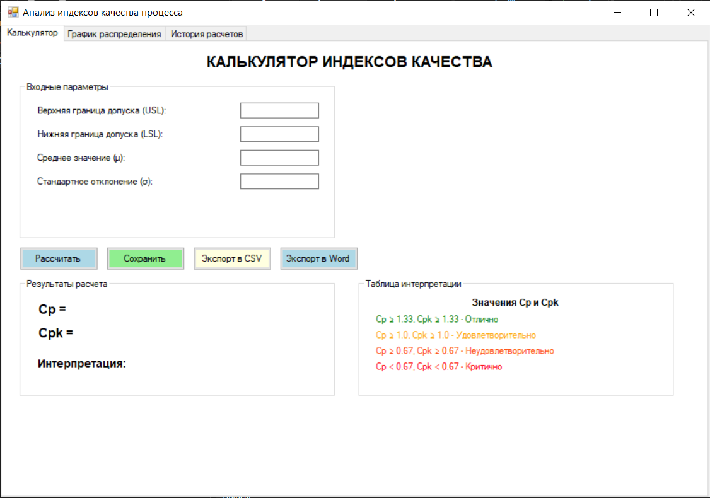
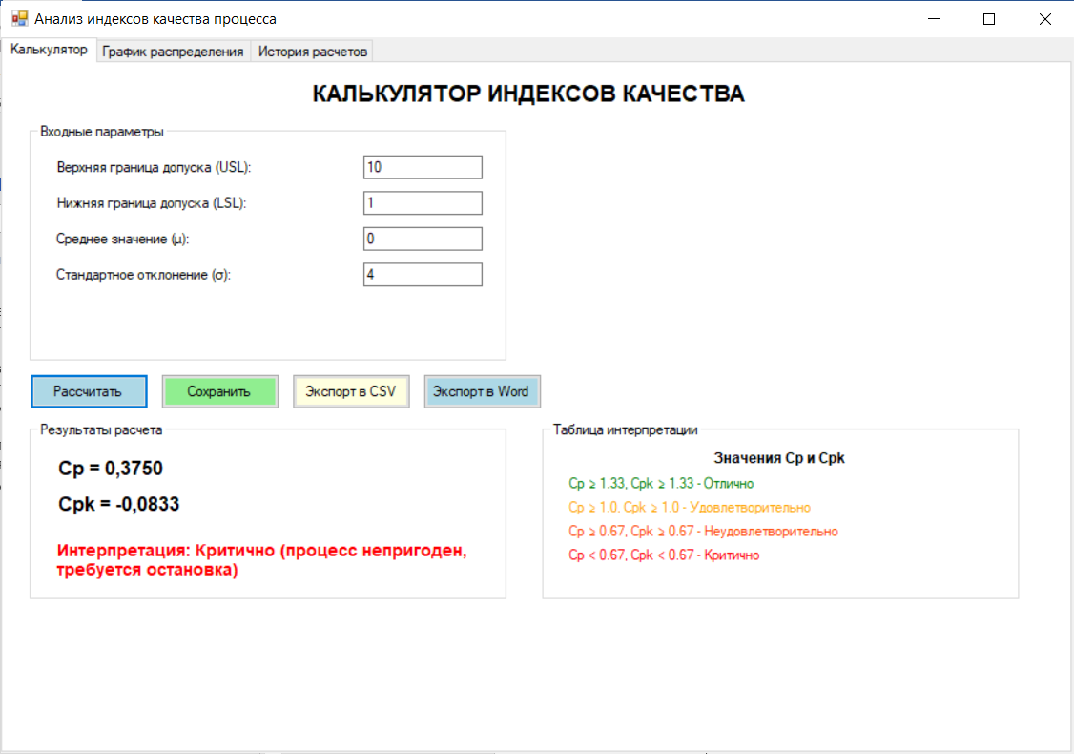
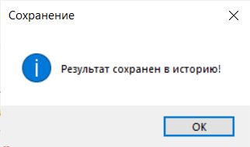
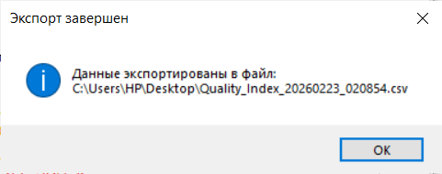
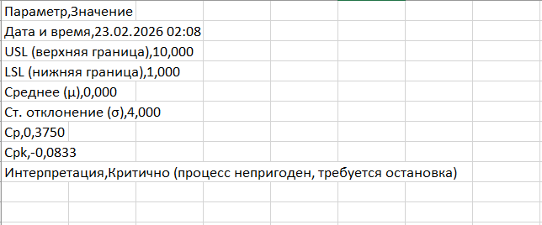
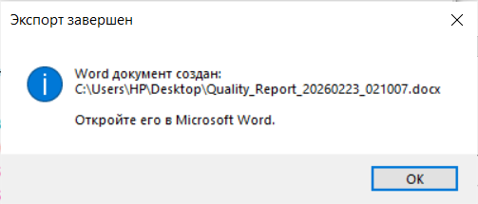

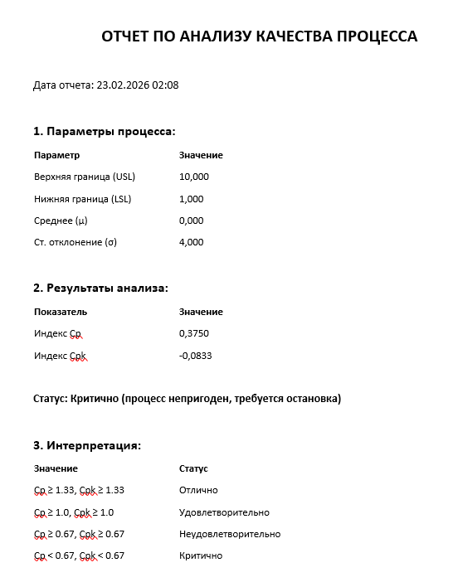
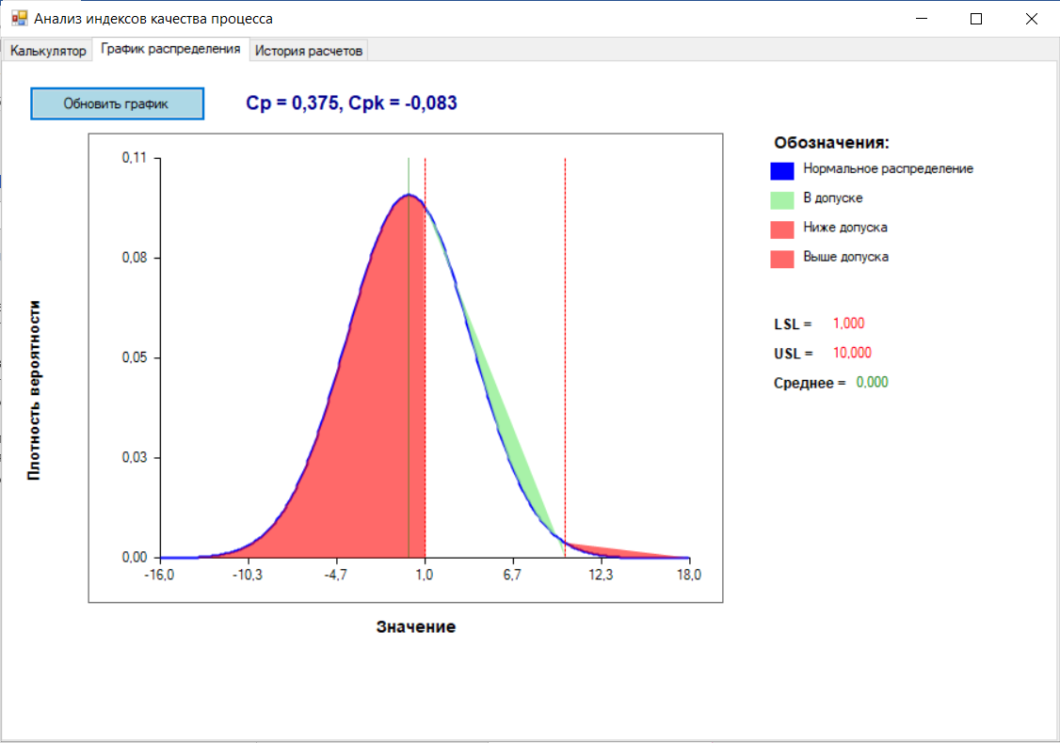
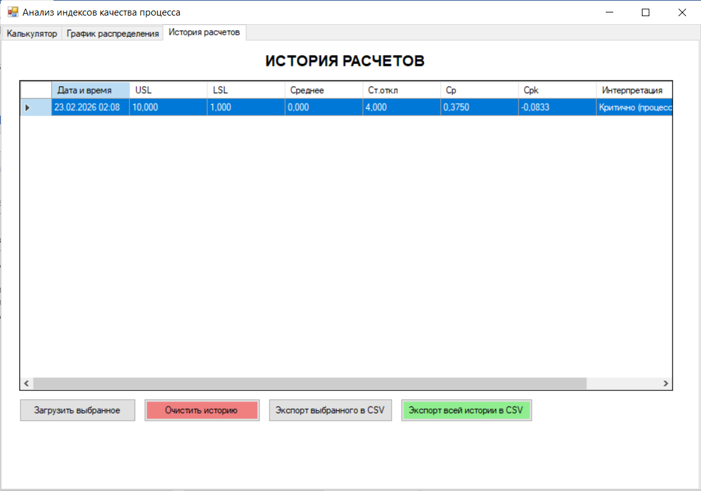
Контрольные вопросы
- На графике доля брака визуально представлена закрашенными областями:
Красная область слева от LSL — продукция ниже нижней границы допуска
Красная область справа от USL — продукция выше верхней границы допуска
- Увеличение стандартного отклонения (σ) оказывает отрицательное влияние на индексы качества
- Для архивирования результатов и сравнивания процессов
- Визуальное определение брака — сразу видно, какая часть продукции выходит за границы допуска (красные области). Оценка центрированности процесса — по положению среднего (μ) относительно границ допуска видно, смещен ли процесс.
- CSV и Word (DOCX)

